Random Forest Regressor - Detailed Learning Handbook

Definition
Random Forest Regressor is an ensemble learning algorithm that combines multiple Decision Trees and averages their predictions to improve accuracy and reduce overfitting.

Category
Machine Learning > Supervised Learning > Regression

Use Cases
House Price Prediction
Demand Forecasting
Sales Prediction
Risk Scoring

Core Concept
Bagging (Bootstrap Aggregation)

Sample Dataset
Feature X | Target Y
1 | 10
2 | 12
3 | 25
4 | 28
5 | 40
6 | 45

Manual Calculation Concept
Tree 1 Prediction = 20
Tree 2 Prediction = 24
Tree 3 Prediction = 22
Final Prediction
= (20+24+22)/3
= 22

Graph Visualization
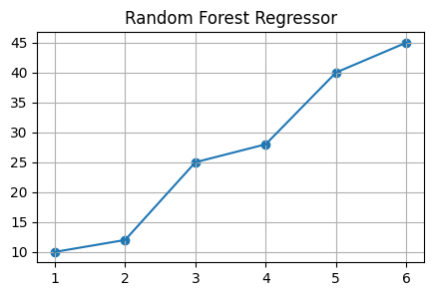

Python Implementation
from sklearn.ensemble import RandomForestRegressor
X=[[1],[2],[3],[4],[5],[6]]
y=[10,12,25,28,40,45]
model=RandomForestRegressor(n_estimators=100, random_state=42)
model.fit(X,y)
prediction=model.predict([[3.5]])
print(prediction)

Important Hyperparameters
n_estimators
max_depth
min_samples_split
min_samples_leaf
max_features

Advantages
High accuracy
Handles non-linear data
Works with large datasets

Limitations
More computationally expensive than Linear Regression

Interview Questions
What is it?
Why use it?
Difference from Decision Tree?
Important hyperparameters?
Real-world use cases?

